Faller car system: Battery replacement with Lipo, Lipo charger and PIC microcontroller PCB.

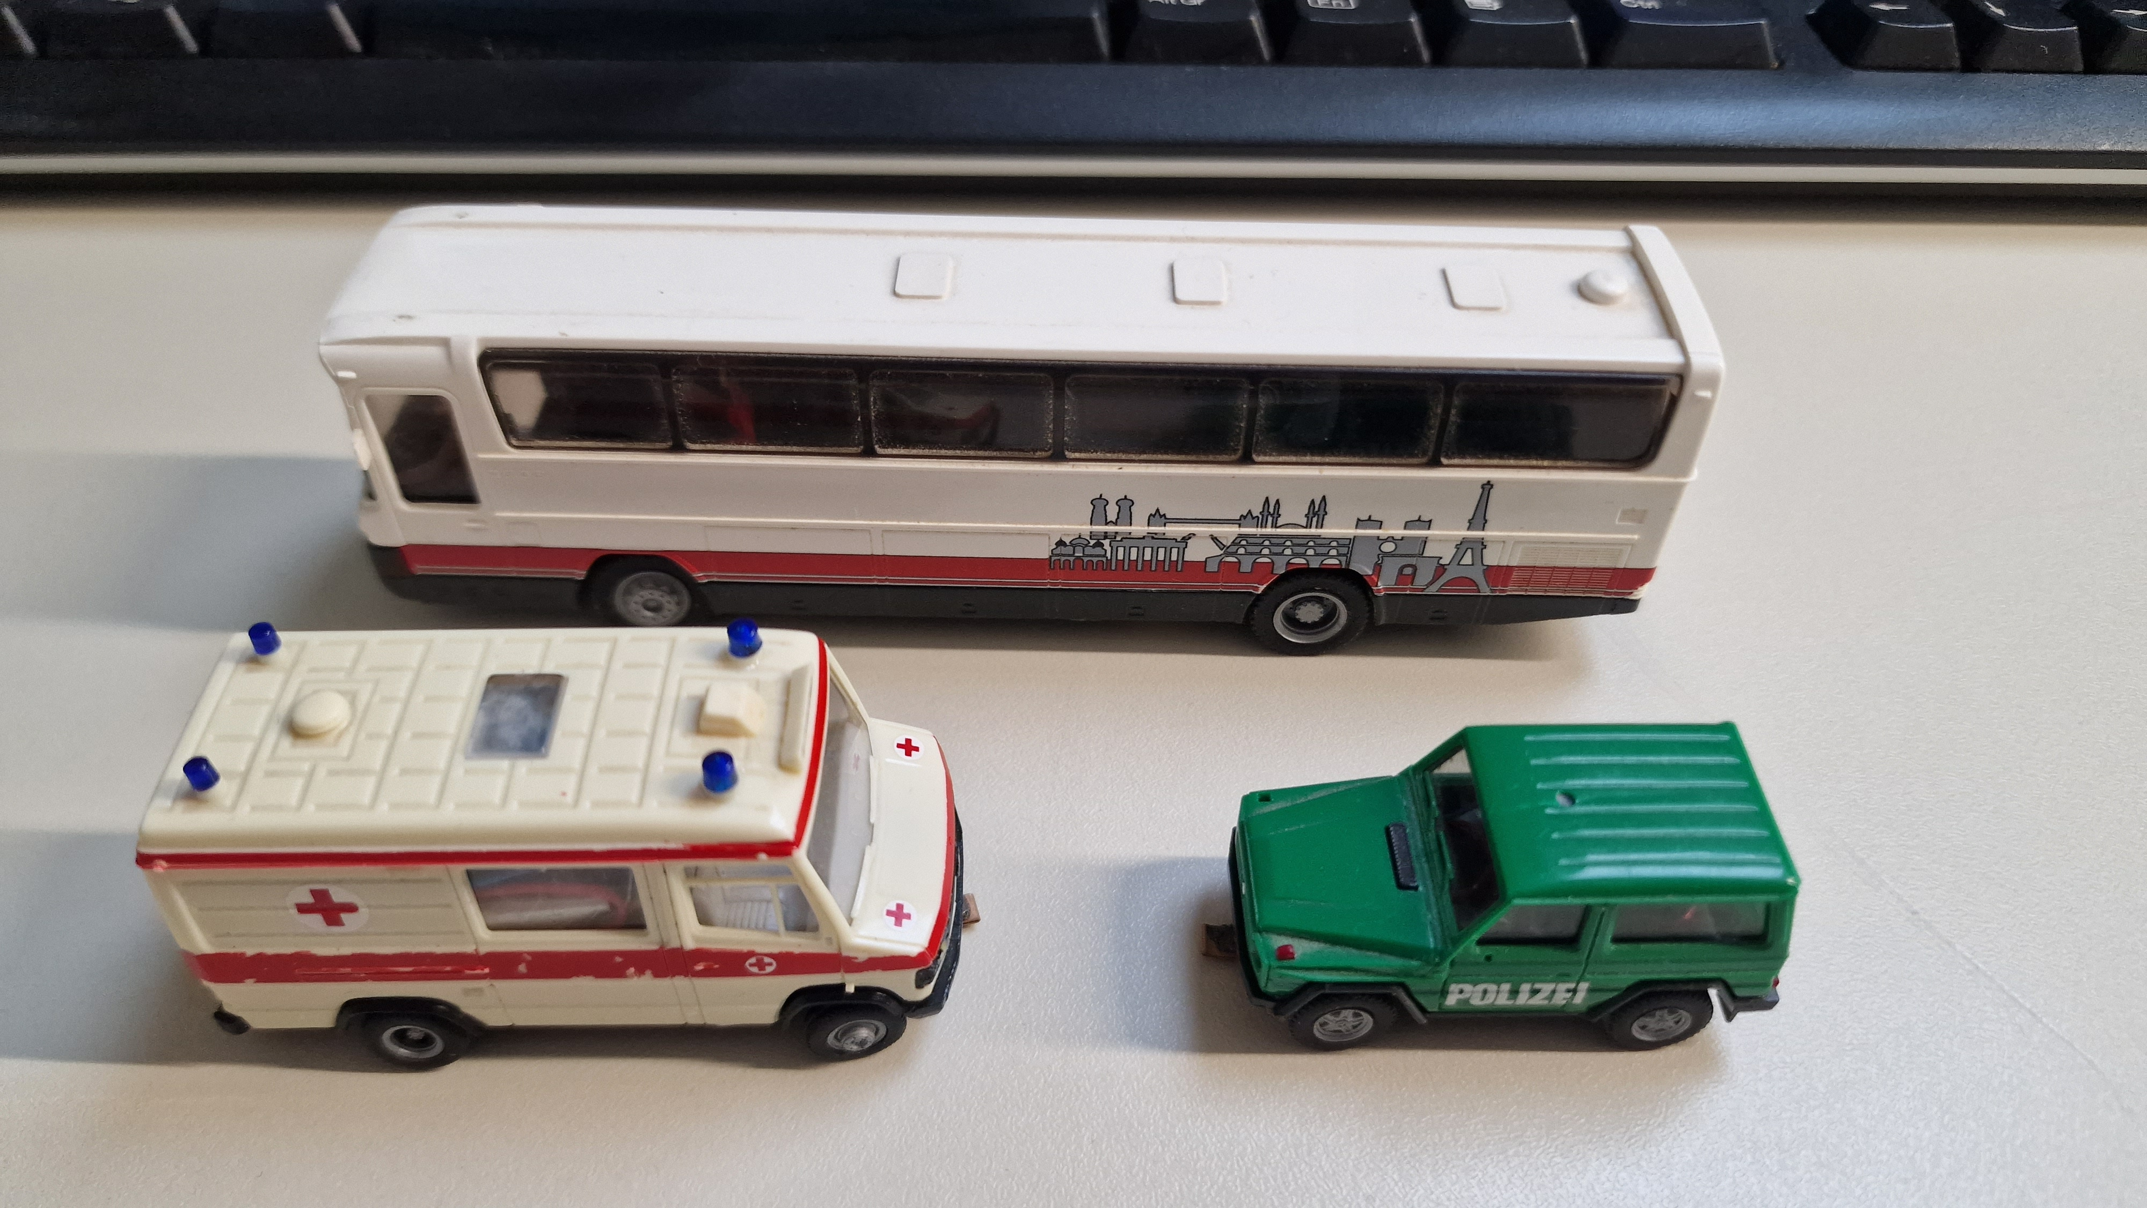
https://youtu.be/njiMmbR584Y

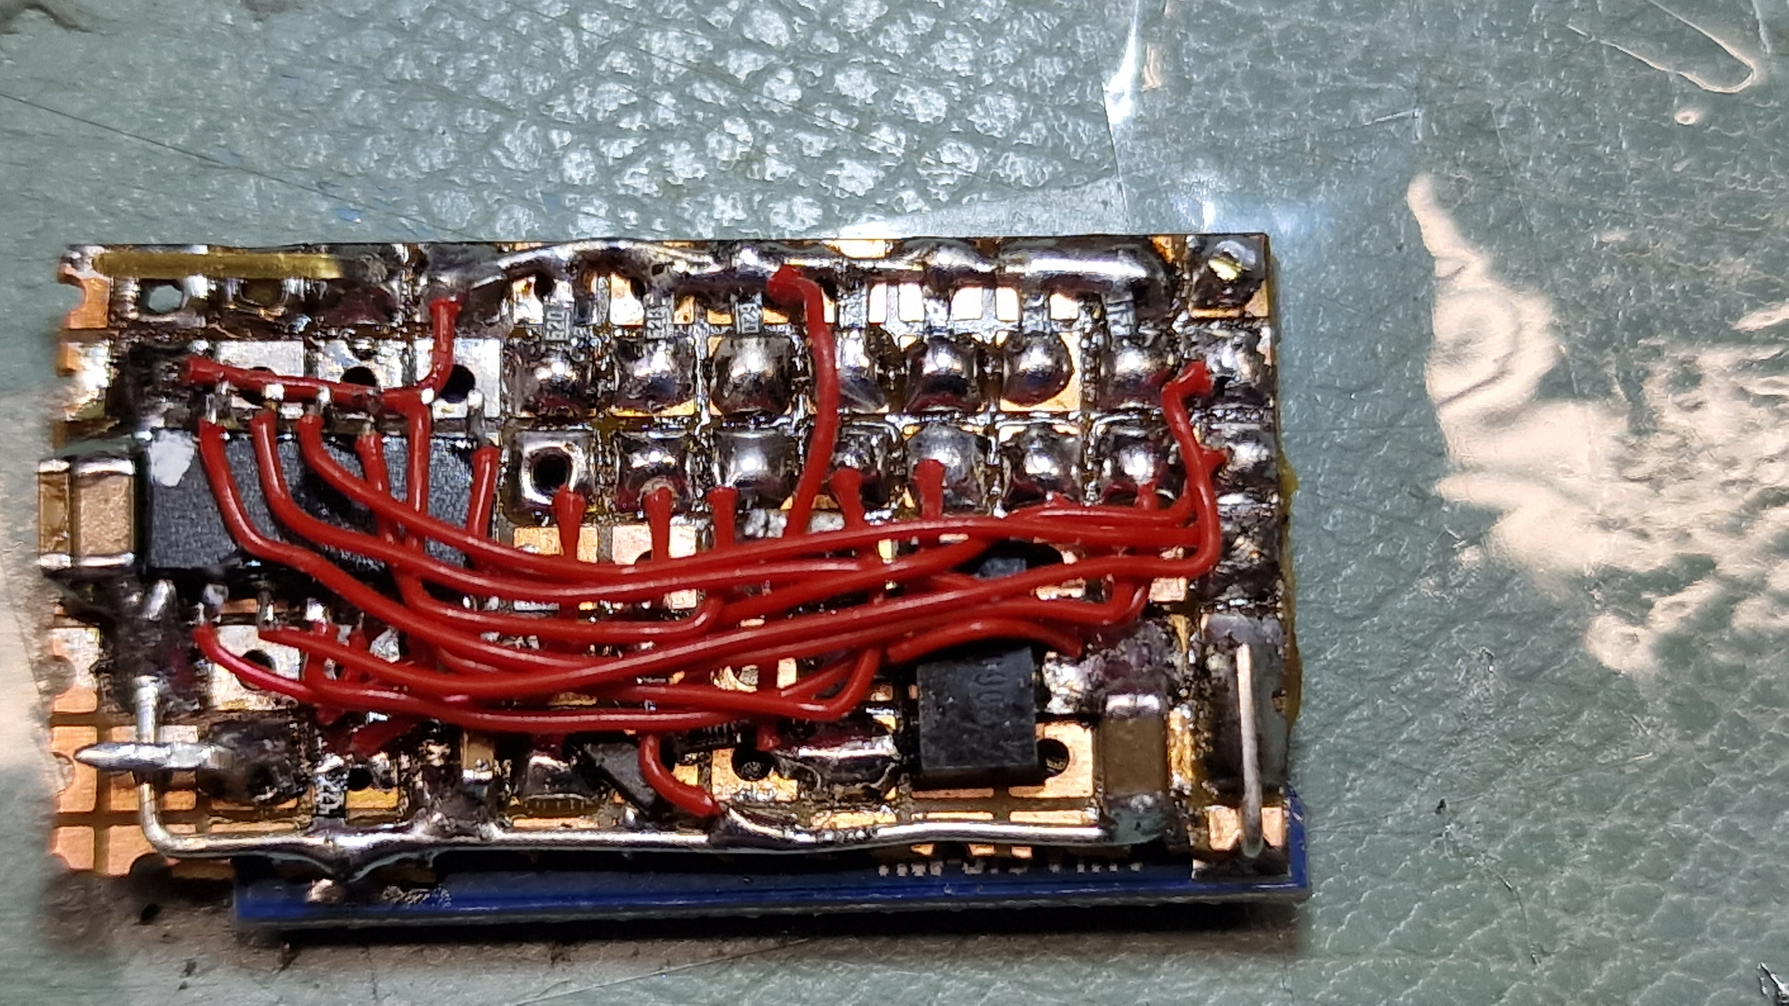
Proto board : KiCad\FallerCarSystem_v1
Proto FW : Faller_Car_ucontroller.X
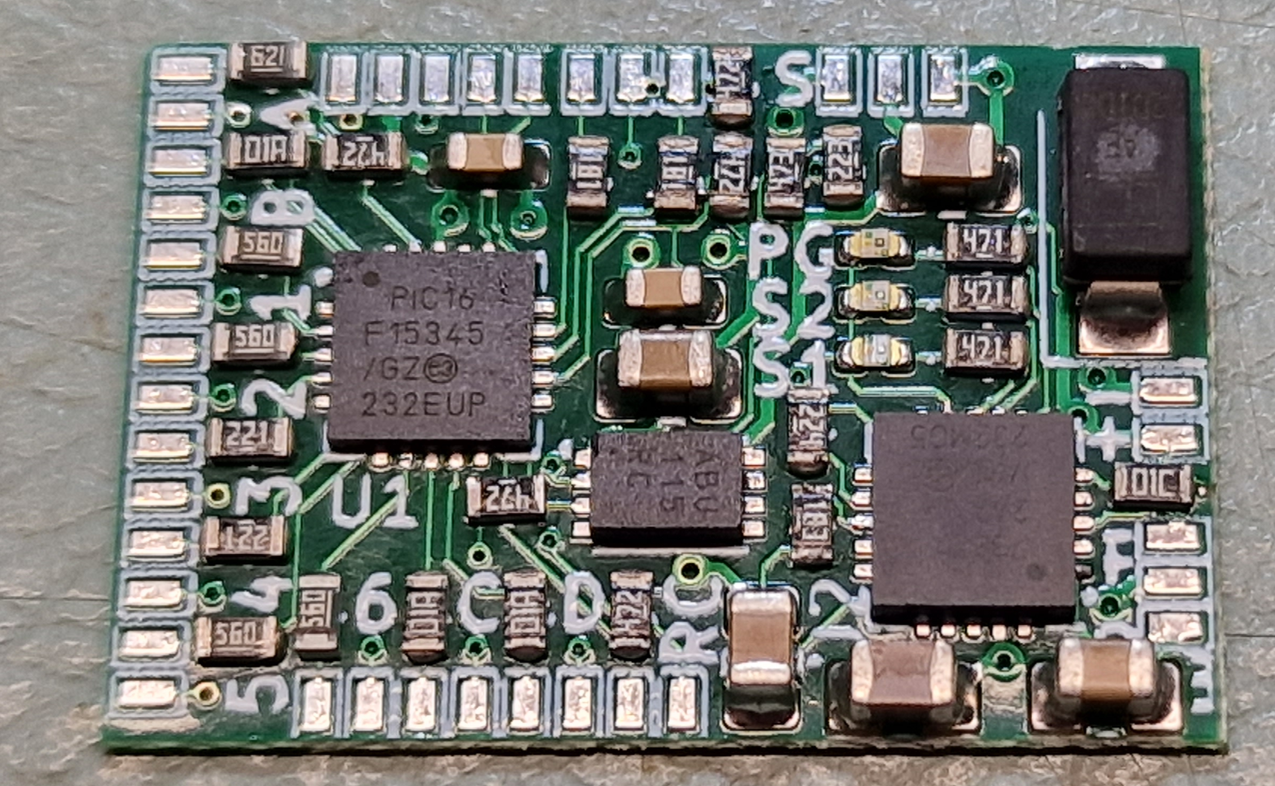
Final board : KiCad\FallerCarSystem_v2
FW : Faller_Car_ucontroller2.X & Faller_Car_uControllerBootLoader.X
Polizei (police) car:

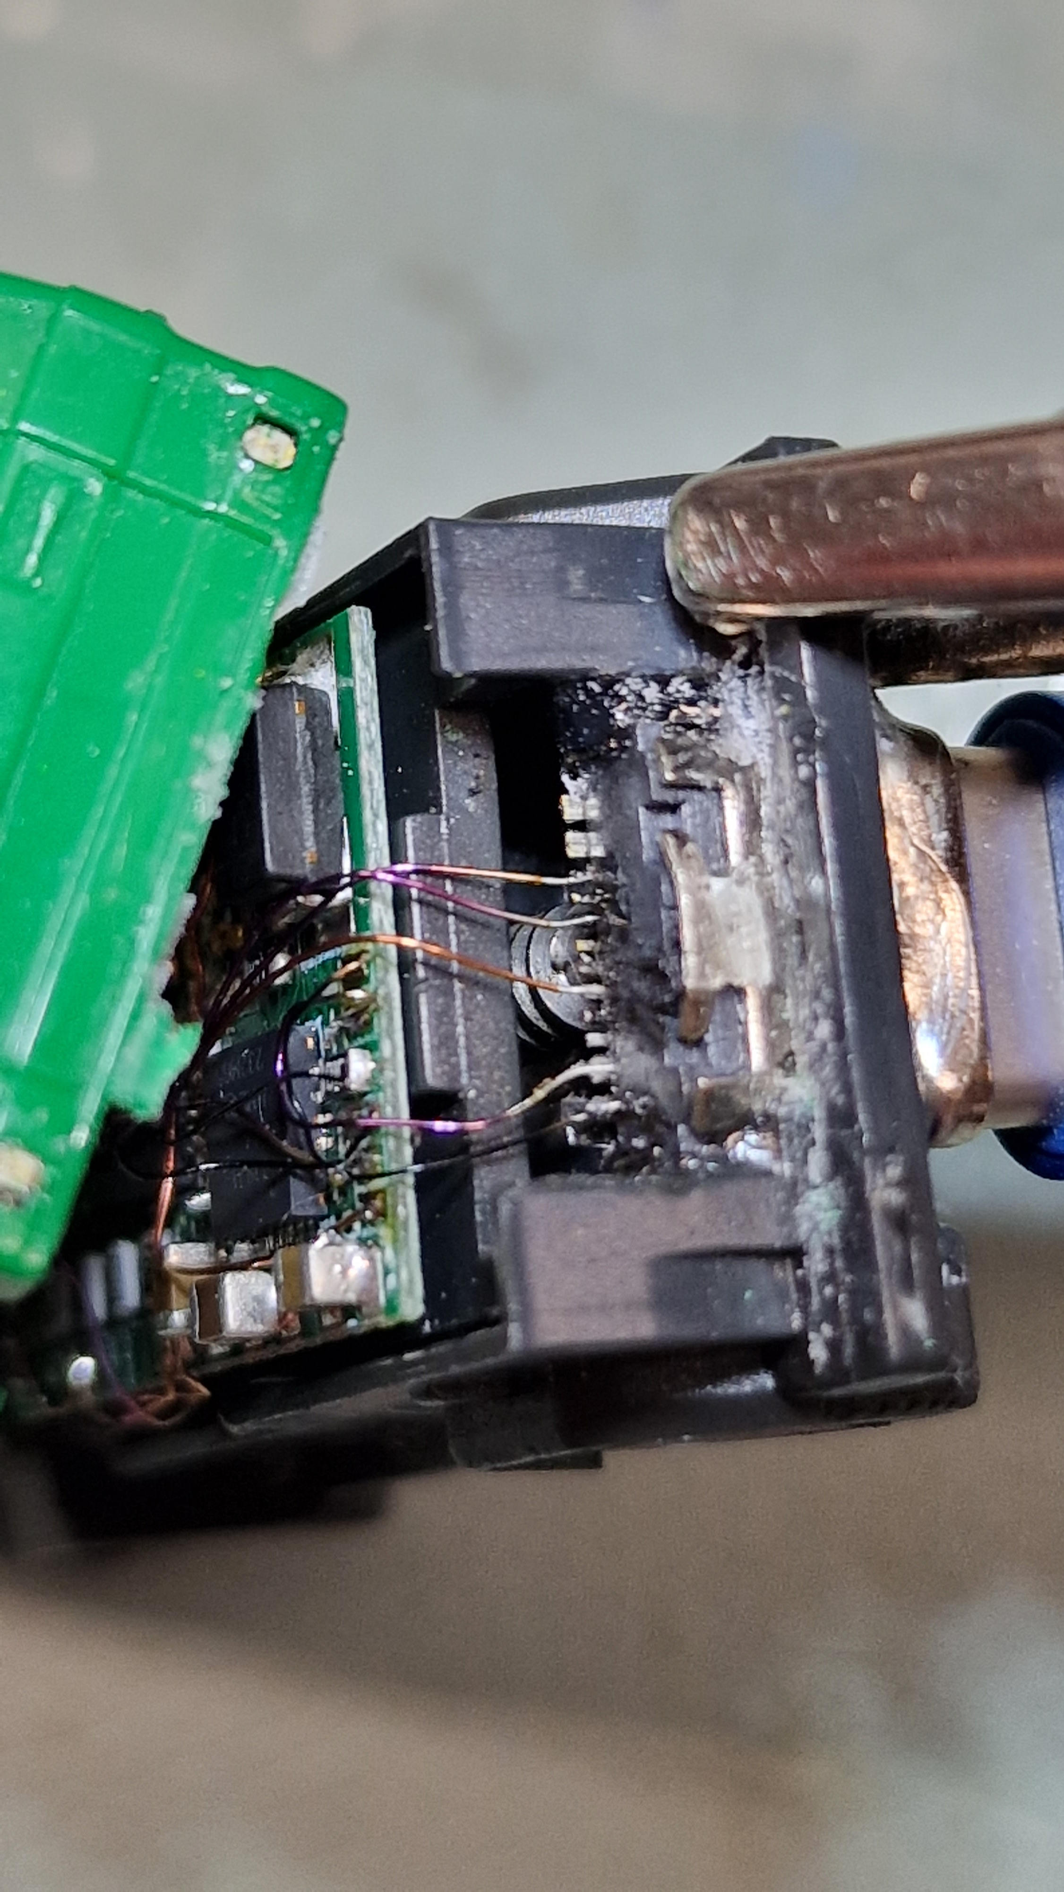
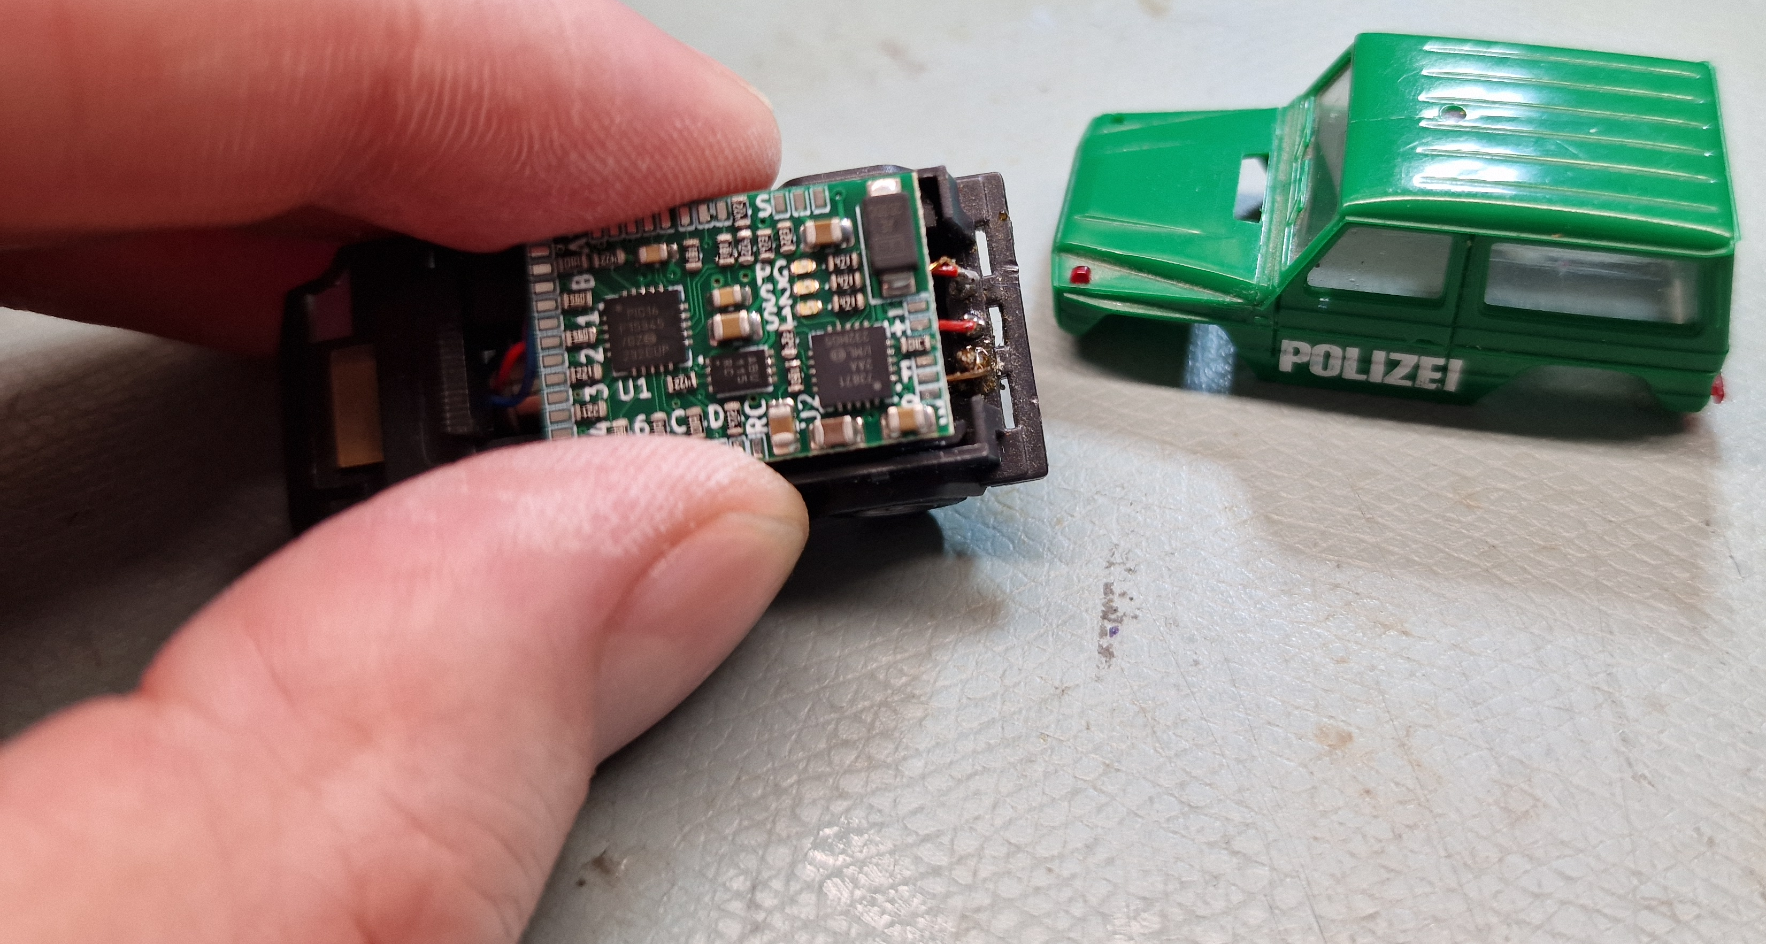
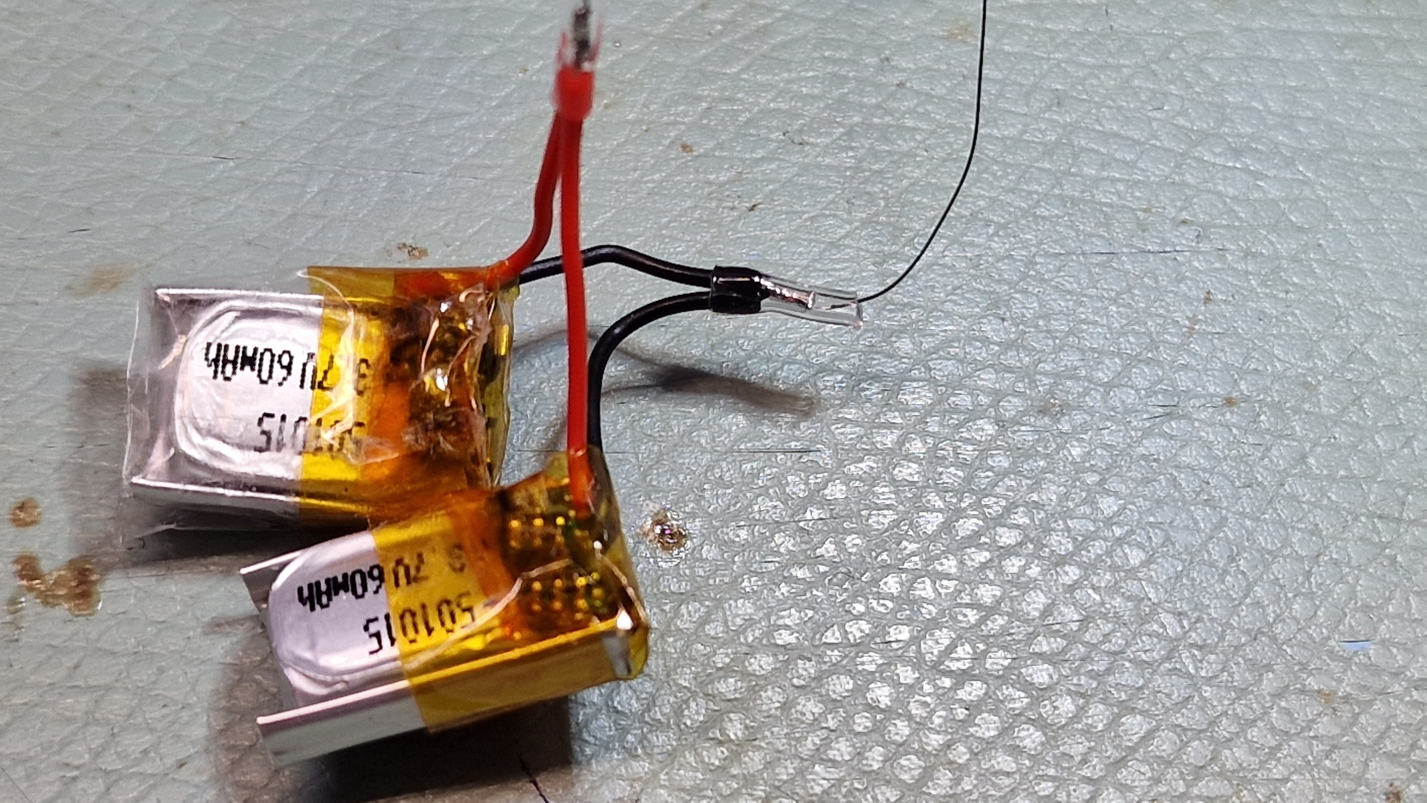
Power switch of the Car disconnects battery from PCB to prevent current leakage.
USB-C 2.0 connector 12 pins – top side
12 = 0V n.c.
11 = 5V n.c.
10 = Bootloader to C-cable wire Yellow
9 = n.c.
8 = TX to C-cable wire Green
7 = n.c.
6 = n.c.
5 = RX to C-cable wire White
4 = n.c.
3 = n.c.
2 = 5V to C-cable wire Red
1 = 0V to C-cable wire Black

`

2x 60mA Lipo
Vpp
5V
Gnd
Data / BootL.
CLK
RX
Gnd
Tx
Vin = Vbatt
M+
M-

Wire Patch: PG pulls MCLR of PIC low while charging.

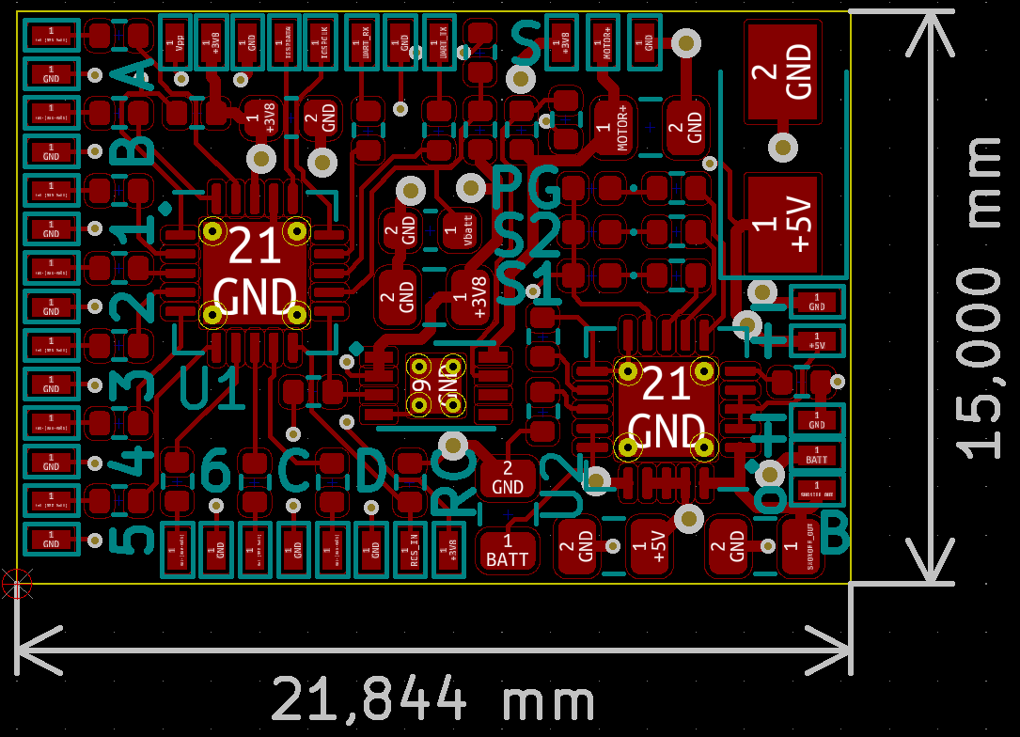
0V
5V charger
0V Batt
4.2V Batt
Vout
Charge resistor current selection = 110mA = 9.1kOhm
LedA = 56 Ohm
Top Flash Light

Led PWM1&2
= 100 Ohm
Blinker lights
Led PWM3&4
= 220 Ohm
Rear Lights
Led PWM5&6
= 56 Ohm
Front Lights
Reed Contact
input & power
Motor voltage set to 1.3V

Blink Front & Back Left 2x 2.1V Orange Led 40Ω PWM1
Blink Front & Back Right 2x 2.1V Orange Led 40Ω PWM2
Back/Brake Left & Right 2x 1.95V Red Led 100Ω PWM3
Cabin Lights 3x 3.0V White Led 56Ω PWM4 3x Mosfet
Front Head Lights 2x 3.0V Warm White Led 56Ω PWM5 2x Mosfet
Vehicle Light 8x 2.1V Orange Led 40Ω PWM6 4x Mosfet
Back Light Up Left 1x 1.95V Red Led 7k5Ω OutputA
Back Light Down Left 1x 1.95V Red Led 7k5Ω OutputC
Back Light Up Right 1x 1.95V Red Led 7k5Ω OutputB
Back Light Down Right 1x 1.95V Red Led 7k5Ω OutputD

Motor voltage = 2.3V
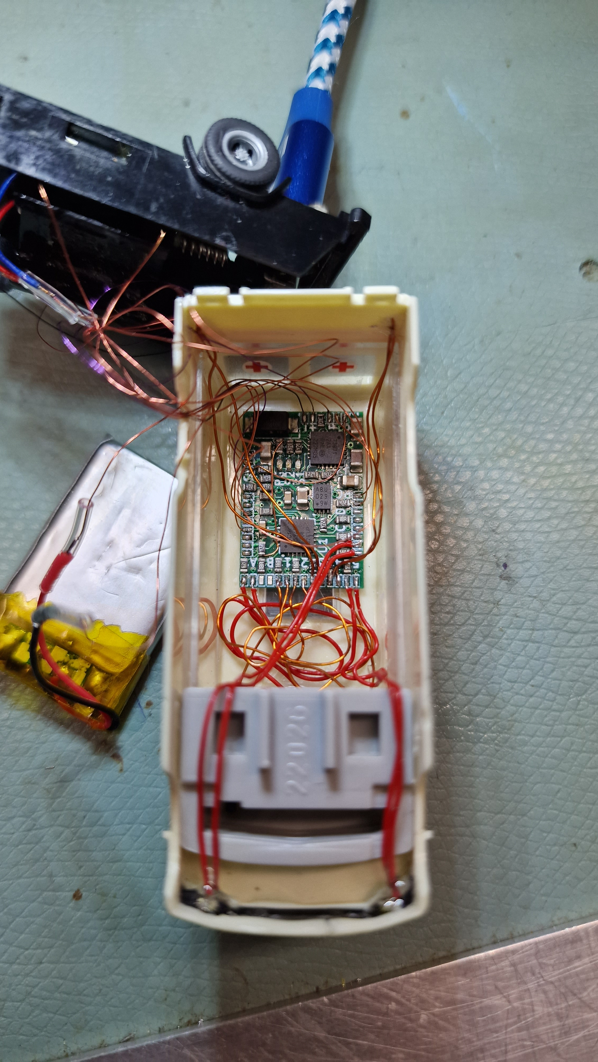
Battery 600mAh 50x22.5x6.3mm
Charge current set to 600mAh = 1.8kΩ

Flash Light Left 1x 3.0V Blue Led 56Ω PWM1
Flash Light Right 1x 3.0V Blue Led 56Ω PWM2
Back/Brake Left 1x 1.95V Red Led 220Ω PWM3
Back/Brake Right 1x 1.95V Red Led 220Ω PWM4
Front Head Lights Left 1x 3.0V Warm White Led 56Ω PWM5
Front Head Lights Right 1x 3.0V Warm White Led 56Ω PWM6
Cabin Light 1x 3.0V White Led 620Ω OutputA

Motor voltage = 1.3V
Battery 200mAh
Charge current set to 200mAh = 4.7kΩ

